Bayesian Optimization

# Bayesian Optimization

We have function f: with to minimize on some domain X . If **a functional form** for f is **not available,** we Bayesian Optimization proceeds by maintaining a probabilistic belief about f and designing an acquisition function to determine where to evaluate the function next.

Bayesian optimization almost always reason about f by choosing an appropriate **Gaussian Process prior**:

Given observation we can condition our distribution D to compute posterior expectation of the function f is look likes . How can select where to observe next? The acquisition function is inexpensive function that evaluated at a given point to measure how desirable evaluating is expected to be for minimization problem. We then can optimize the acquisition to select region of domain of f are optimal (location of next observation).

# Gaussian Process

For the prior distribution, assume function f can be described by a Gaussian Process (GP). For data point we assume value of the function can be described by a multivariate Gaussian distribution

The joint distribution of training output f and test output according to the prior without taking count of noise is

we can obtain posterior distribution from the prior:

However, to compute posterior, we need both likelihood model for the samples from f and prior probability model on f. We can assume normal likelihood with noise

Because the likelihood and prior are conjugate so we can obtain marginal likelihood of training output as

# Acquisition function

To find the best point to sample next, we need an objective function that is acquisition function. This is a function of **the posterior distribution over f** that describes the utility of all values of the hyper parameter. As be mentioned above, we choose the point to maximize acquisition function to evaluate next.

Probability of improvement

is the minimal value of f observed. PI evaluate f at the point most likely to improve on this value. Utility function associated with evaluating f at a given point x:

The probability of improvement acquisition function is expected utility as a function of x. The point with highest probability of improvement is selected

Expected improvement

It is similar with PI but it takes count the size of the improvement. EI evaluate f at the point in expectation most improvement. This corresponds to the following utility function

The expected improvement acquisition function then the expected utility as a function of x. The point with highest expected improvement is selected

where and are the cumulative distribution and probability density of multivariate normal distribution. EI has 2 components. The first can increase by reduce mean of function and the second can increase by increasing variance . These 2 terms can be interpreted as a tradeoff between **exploitation** (points with low means) and **exploration** (points with high uncertainty).

It is intuitive to understand that we want to sample from the point which we expect smaller value of or points in the regions of we haven’t explore it yet that is high.

Entropy Search

We seek to **minimize the uncertainty** we have **in the location of the optimal value**. . ES seek to evaluate points so as to minimize the entropy of the induced distribution .

This is can be done by, first, computing current amount of information H about minimum. Second, approximate the expected information gain at certain location. Finally, suggesting next evaluation point where is maximize. Utility function at x

*P/s: Amount of information about the location of minimum is computed

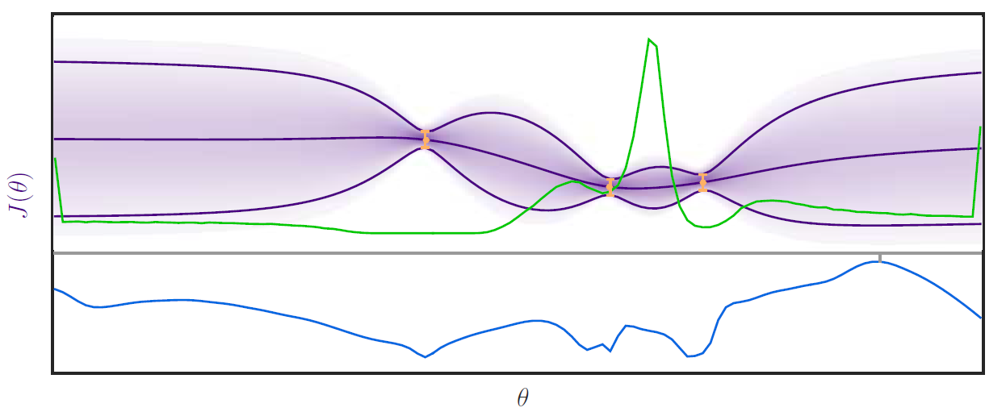

Figure Approximated probability distribution over the location of the minimum p_min(Θ) in green and The blue line represents the expected gain in information E [ΔH] (Θ).

Our entropy search acquisition function then the expected utility as a function of x

Due to no closed-form expression for distribution of . A series of approximation must be made